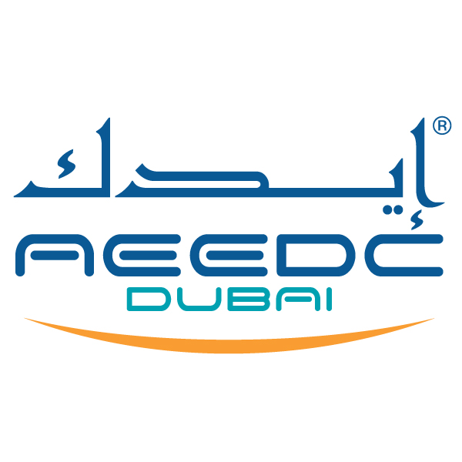

UAE International Dental Conference & Arab Dental Exhibition
AEEDC Dubai 2025
4-6 February 2025

Dubai World Trade Centre

Excellence in Clinical Equipment Award

Application Form

Deadline: 20th December 2024
For office use only

Date Rcvd. ______________________

Reg. No. ________________________

Abs. No. ________________________

Please complete and submit this form to:
INDEX Conferences & Exhibitions Organisation LLC.
P.O. Box: 13636, Dubai – United Arab Emirates
Tel: +97145208888, Fax: +97143384193
E-mail: pratik.manghnani@index.ae

Manufacturer Name and Profile: (the corporate entity or individual holding ownership of the product).
Product / Brand Name:
Product Profile:
Describing the product and its intended use (300 characters maximum, including spaces).

Region: | UAE GCC & MENA region International (specify_______________________)
What Makes This Product a Winner: (Maximum of 200 words)
Collect Relevant Supporting Material Including High Resolution Photographs Saved in a Jpeg Format | Kindly label and attach your supporting materials and photos.
Collect relevant recommended Items:
The following materials are recommended (not required) to supplement your entry as an aid to jurors during the judging process. Please note that submitting either a sample product or a product demo video is NOT required, however most entries usually include either a sample product, or a product video in lieu of a sample product, or both.
- Additional photos and diagrams.
- Sample products.
- Short product demo video (5 minutes or less) which focuses clearly on the product’s design features and demonstrates how the product is used.
- Product marketing brochures.

(All entered products must be commercially available— able to be ordered or purchased)

Contact Information
Name:
Tel:
Mob:
Fax:
Email:
Address:
Forms not complying with the specified format will not be considered.

Participation Guidelines:

*(The term organiser means INDEX Conferences & Exhibitions Organisation LLC.)
- The form must be in English, font size 12 in Times New Roman font and with single-line spacing.
- Excellence in Dental Laboratory Award is open for exhibitor and non exhibiting companies.
- Form should be submitted by e-mail to pratik.manghnani@index.ae Abstracts that are handwritten, or sent by fax will not be accepted.
- The AEEDC Awards’ Committee will evaluate the content of each form and make the final selection of the winner.
- No form will be considered after 20th December 2024.
- For any withdrawals, the presenter should notify the *organiser in writing at least 1 month prior to the event.
Signature: Date of application:

